Website Project Proposal
Organization Name: Hope Traditional Kitchen
- Organization Overview
Hope Traditional Kitchen is a traditional South African restaurant founded in 2015 in Polokwane. It specializes in authentic home-style cuisine such as pap, stews, braai meats and traditional desserts.

Mission: To serve authentic, wholesome traditional South African food that brings families and communities together while honoring cultural heritage.

Vision: To become the leading traditional food restaurant in Polokwane, known for quality, authenticity and warm hospitality. Target audience: Local families, working professionals, tourists and corporate groups (ages 25 - 55).

- Website Goals and Objectives
The website will act as the main digital storefront. Goals include:
- Increase website traffic by at least 40% in six months
- Enable online table reservations and takeaway orders
- Showcase the full menu and restaurant story
- Build an email/WhatsApp subscriber list
Key Performance Indicators (KPIs): monthly unique visitors, number of online reservations, conversion rate from visit to booking, and average time spent on the menu page.
- Current Website Analysis
The restaurant currently has no dedicated website and relies on Facebook, Instagram and Google Business. While social media engagement is strong and reviews are positive, limitations include no central online menu, no online booking system, and poor search engine visibility.
- Proposed Website Features and Functionality
Essential pages and features:
- Homepage with hero images, introduction and clear call-to-action buttons.
- About Us page telling the founder’s story.
- Full online products page with categories, prices and dietary filters.
- Contact page with form, Google Maps, hours and contact details.
- Enquiry page with form and enquiring details.
- Design and User Experience
Design will reflect warmth and heritage using earthy brown, terracotta, cream and soft green colors. Serif headings and clean sans-serif body text will be used. The layout will be mobile-first, clean and spacious with large food photography and simple navigation. Low-fidelity wireframes will guide the information hierarchy.

Wireframes

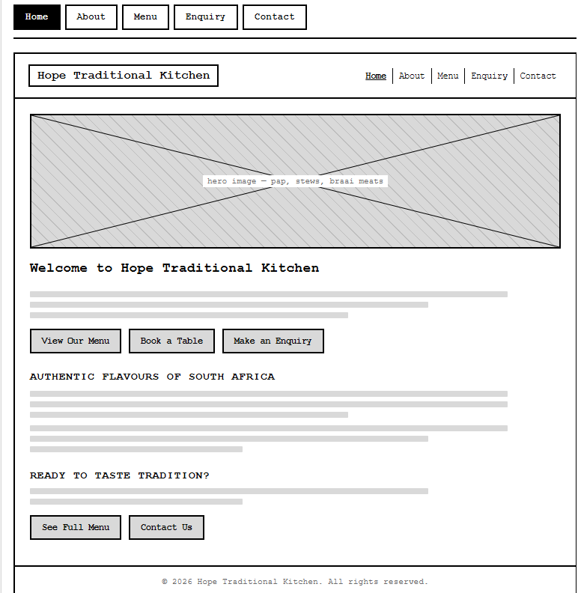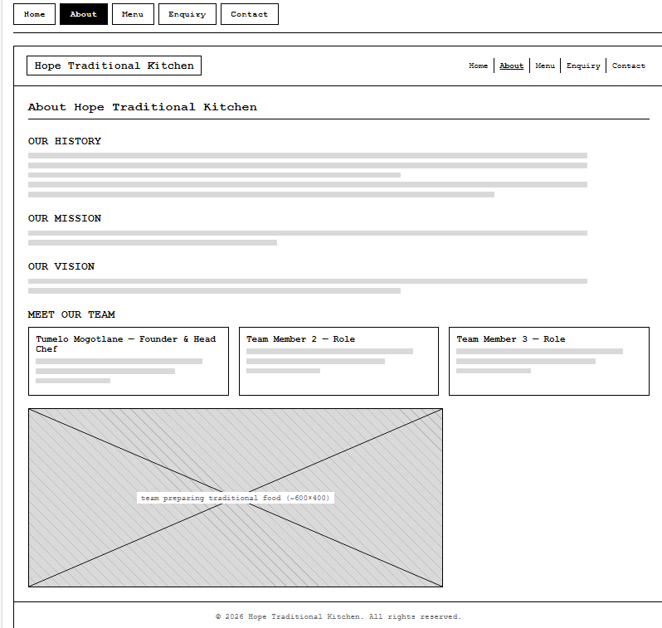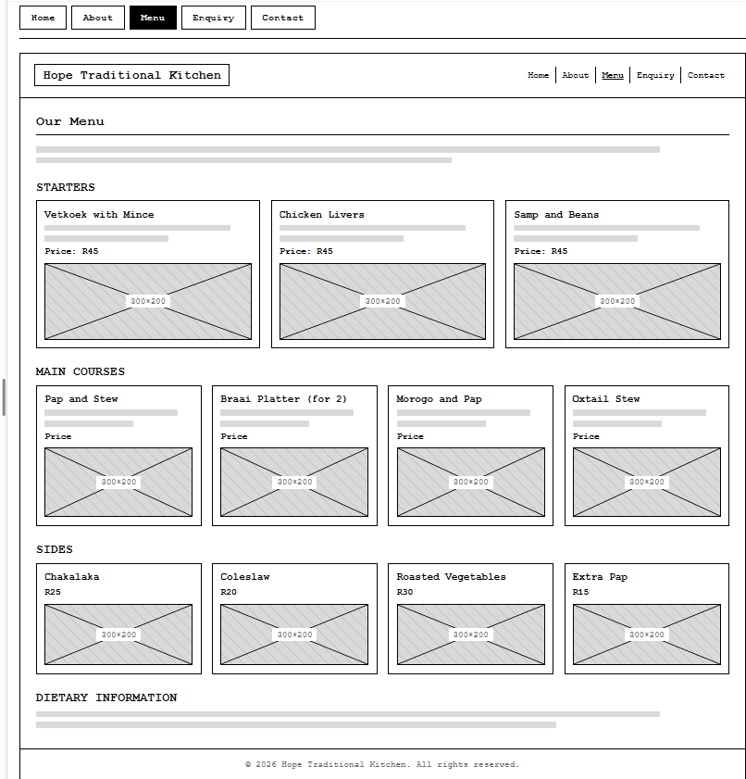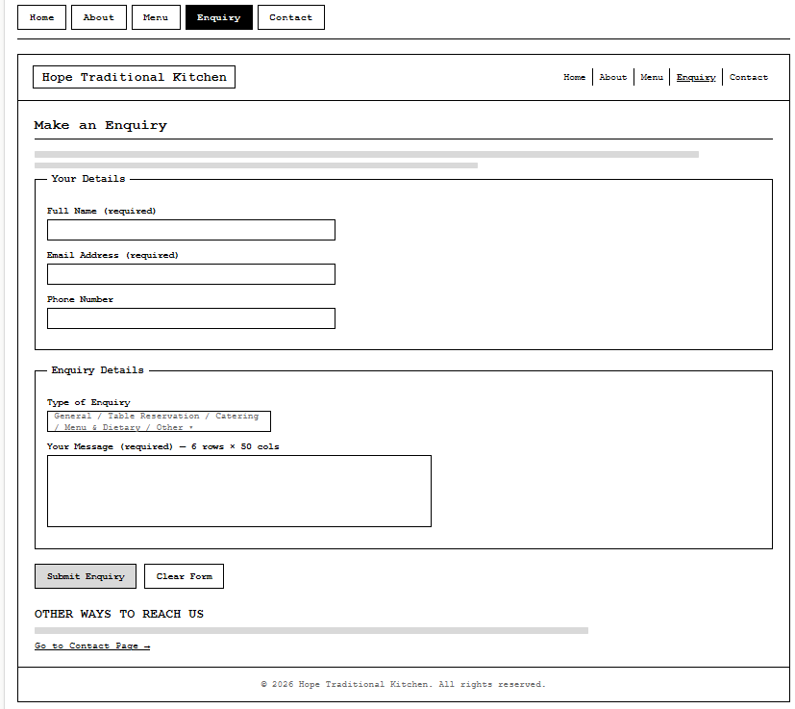

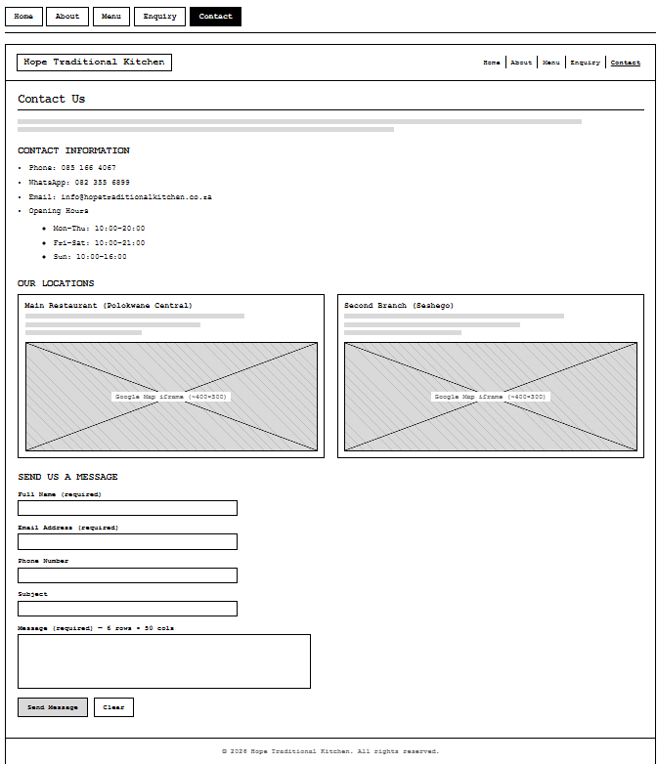

- Technical Requirements
Built with HTML5, CSS3 and JavaScript. A simple CMS (such as WordPress) will allow easy menu updates. Hosting will use a reliable South African provider with SSL. Recommended domain: hopetraditionalkitchen.co.za. Integrations include Google Maps and basic analytics.

- Timeline and Milestones
Approximate 8 - 10 week schedule:
- Weeks 1–2: Content collection and wireframes
- Weeks 3–4: Visual design and feedback
- Weeks 5–7: Development and CMS setup
- Week 8: Testing
- Week 9: Launch
- Week 10: Handover and support
- Budget
Estimated first-year costs (South African rates):
- Domain: R150–R250 per year
- Hosting: R100–R250 per month
- Design and development: R12 000–R25 000
- Photography (optional): R3 000–R6 000
- Annual maintenance: R2 000–R4 000
Total first-year estimate: R18 000–R35 000.

- References
BentoBox, 2024. 10 Essential Elements + Design Tips for Restaurant Websites. Available at: https://www.getbento.com/blog/the-10-essential-elements-of-a-restaurant-website/ [Accessed 12 August 2026].
Google, n.d. Search Central – Local SEO documentation. Available at: https://developers.google.com/search/docs [Accessed 11 August 2026].
Juicy Designs, 2025. Website Creation Cost in South Africa: Full Picture. Available at: https://www.juicydesigns.co.za/blog/website-creation-cost-south-africa/ [Accessed 14 August 2026].
Nielsen Norman Group, 2024. Menu-Design Checklist: 17 UX Guidelines. Available at: https://www.nngroup.com/articles/menu-design/ [Accessed 13 August 2026].
OpenTable, 2024. How to Build a Restaurant Website: Complete Guide + Examples. Available at: https://www.opentable.com/restaurant-solutions/resources/restaurant-website-creation/ [Accessed 14 August 2026].

